# Was taken from here: “20180830 How to change alerts schedule from streams from one graylog server to other”.

#
# Here is article, that helps me to made need for me filter of json output:
# https://shapeshed.com/jq-json/
#

[root@vm-vol-nag4-prod ~]# curl -u trading_api:***** -H 'Accept: application/json' -X GET 'https://ha-graylog.tcsbank.ru:443/api/streams/589477a932f0673c83382f7e/' --insecure | jq '.'
% Total % Received % Xferd Average Speed Time Time Time Current
Dload Upload Total Spent Left Speed
101 1012 101 1012 0 0 5801 0 --:--:-- --:--:-- --:--:-- 10652
{
"is_default": false,
"index_set_id": "5954a92d1a36d83dd228bacc",
"remove_matches_from_default_stream": true,
"content_pack": null,
"title": "[ALERT] (TRADING) Fall Buy success operations",
"alert_receivers": {
"users": [],
"emails": []
},
"alert_conditions": [],
"id": "589477a932f0673c83382f7e",
"creator_user_id": "o.a.filippova",
"outputs": [],
"matching_type": "AND",
"description": "MON-256 (покупка+продажа)",
"created_at": "2017-02-03T12:29:29.627Z",
"disabled": false,
"rules": [
{
"value": "order/confirm",
"inverted": false,
"type": 1,
"id": "5894782832f0673c83383031",
"description": "",
"stream_id": "589477a932f0673c83382f7e",
"field": "operation"
},
{
"value": "OK",
"inverted": false,
"type": 1,
"id": "589478de32f0673c8338312e",
"description": "",
"stream_id": "589477a932f0673c83382f7e",
"field": "result"
},
{
"value": "((ds|m1)-mss-tta-(uat|prod)-api0(1|2).tcsbank.ru)|((m1|ds)-mss-tta-prod-api0(3|4).tcsbank.ru)",
"inverted": false,
"type": 2,
"id": "5ab4dfb11a36d80ba4e9c3bc",
"description": "",
"stream_id": "589477a932f0673c83382f7e",
"field": "source"
}
]
}
[root@vm-vol-nag4-prod ~]#

[root@vm-vol-nag4-prod ~]# curl -u trading_api:***** -H 'Accept: application/json' -X GET 'https://ha-graylog.tcsbank.ru:443/api/streams/589477a932f0673c83382f7e/' --insecure | jq '.title'
% Total % Received % Xferd Average Speed Time Time Time Current
Dload Upload Total Spent Left Speed
101 1012 101 1012 0 0 5564 0 --:--:-- --:--:-- --:--:-- 9370
"[ALERT] (TRADING) Fall Buy success operations"
[root@vm-vol-nag4-prod ~]#

[root@vm-vol-nag4-prod ~]# curl -u trading_api:***** -H 'Accept: application/json' -X GET 'https://ha-graylog.tcsbank.ru:443/api/streams/589477a932f0673c83382f7e/' --insecure | jq '.title,.creator_user_id,.description,.rules[2].value'
% Total % Received % Xferd Average Speed Time Time Time Current
Dload Upload Total Spent Left Speed
101 1012 101 1012 0 0 5948 0 --:--:-- --:--:-- --:--:-- 11244
"[ALERT] (TRADING) Fall Buy success operations"
"o.a.filippova"
"MON-256 (покупка+продажа)"
"((ds|m1)-mss-tta-(uat|prod)-api0(1|2).tcsbank.ru)|((m1|ds)-mss-tta-prod-api0(3|4).tcsbank.ru)"
[root@vm-vol-nag4-prod ~]#

# Silent mode of curl.
[root@vm-vol-nag4-prod ~]# curl -u trading_api:***** -H 'Accept: application/json' -X GET 'https://ha-graylog.tcsbank.ru:443/api/streams/589477a932f0673c83382f7e/' --insecure --silent | jq '.title,.creator_user_id,.description,.rules[2].value'
"[ALERT] (TRADING) Fall Buy success operations"
"o.a.filippova"
"MON-256 (покупка+продажа)"
"((ds|m1)-mss-tta-(uat|prod)-api0(1|2).tcsbank.ru)|((m1|ds)-mss-tta-prod-api0(3|4).tcsbank.ru)"
[root@vm-vol-nag4-prod ~]#

#
# I’ve gotten info about Stream ID from Евгений Долматов.
# He printed info - what alerts need to be changed.
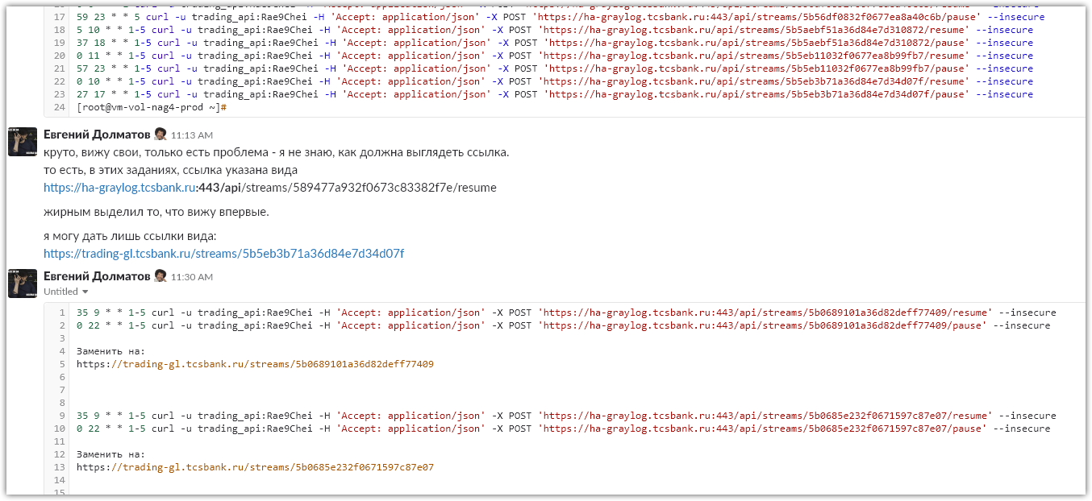

# New Stream ID can be found here. It’s a part of URL to it.
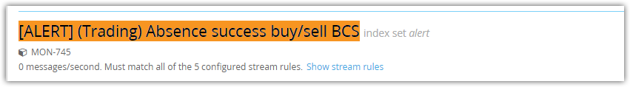
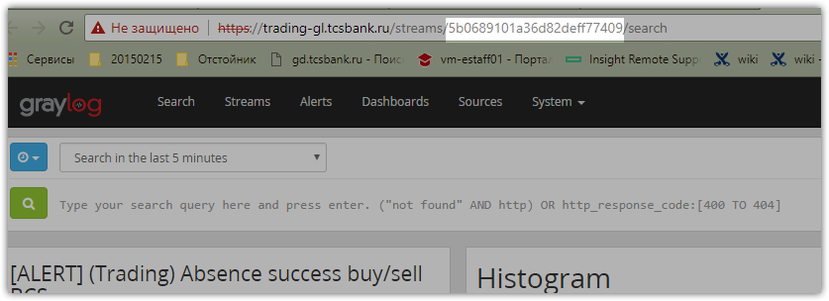

# I tried to test the first line.
[root@vm-vol-nag4-prod ~]# curl -u trading_api:***** -H 'Accept: application/json' -X GET 'https://ha-graylog.tcsbank.ru/api/streams/5b0689101a36d82deff77409/' --insecure --silent | jq '.title,.creator_user_id,.description,.rules[2].value'
"[ALERT] (Trading) Absence success buy/sell BCS"
"o.a.filippova"
"MON-745"
"((ds|m1)-mss-tta-(uat|prod)-api0(1|2).tcsbank.ru)|((m1|ds)-mss-tta-prod-api0(3|4).tcsbank.ru)"
[root@vm-vol-nag4-prod ~]#

# Here I’ve changed server name and Stream ID.
# And have gotten nothign.
[root@vm-vol-nag4-prod ~]# curl -u trading_api:***** -H 'Accept: application/json' -X GET 'https://trading-gl.tcsbank.ru/api/streams/5b0689101a36d82deff77409/' --insecure --silent | jq '.title,.creator_user_id,.description,.rules[2].value'
[root@vm-vol-nag4-prod ~]#

[root@vm-vol-nag4-prod ~]# curl -u trading_api:***** -H 'Accept: application/json' -X GET 'https://trading-gl.tcsbank.ru/api/streams/5b0689101a36d82deff77409/' --insecure | jq '.title,.creator_user_id,.description,.rules[2].value'
% Total % Received % Xferd Average Speed Time Time Time Current
Dload Upload Total Spent Left Speed
0 0 0 0 0 0 0 0 --:--:-- --:--:-- --:--:-- 0
[root@vm-vol-nag4-prod ~]#

#
# That was because appropriate local user “trading_api” was not created on GrayLog server trading-gl.tcsbank.ru.
# Before, I had supposed that password was differ, but the user was absent at all...

# I’ve created the user and assing to it new password.
# After that, recuqest start work properly.
#
[root@vm-vol-nag4-prod ~]# curl -u trading_api:***** -H 'Accept: application/json' -X GET 'https://trading-gl.tcsbank.ru/api/streams/5b0689101a36d82deff77409/' --insecure | jq '.title,.creator_user_id,.description,.rules[2].value'
% Total % Received % Xferd Average Speed Time Time Time Current
Dload Upload Total Spent Left Speed
101 1833 101 1833 0 0 9126 0 --:--:-- --:--:-- --:--:-- 13187
"[ALERT] (Trading) Absence success buy/sell BCS"
"a.leonov"
"MON-745"
"Tinkoff"
[root@vm-vol-nag4-prod ~]#

#
# Some name of Streams were not changed.
#
[root@vm-vol-nag4-prod cron]# curl -u trading_api:***** -H 'Accept: application/json' -X GET 'https://ha-graylog.tcsbank.ru/api/streams/5b0685e232f0671597c87e07/' --insecure --silent | jq '.title,.creator_user_id,.description,.rules[2].value'
"[ALERT] (Trading) Absence success buy/sell Tinkoff"
"o.a.filippova"
"MON-745"
"Tinkoff"
[root@vm-vol-nag4-prod cron]# curl -u trading_api:***** -H 'Accept: application/json' -X GET 'https://trading-gl.tcsbank.ru/api/streams/5b0685e232f0671597c87e07/' --insecure --silent | jq '.title,.creator_user_id,.description,.rules[2].value'
"[ALERT] (Trading) Absence success buy/sell Tinkoff"
"a.leonov"
"MON-745"
"Tinkoff"
[root@vm-vol-nag4-prod cron]#

[root@vm-vol-nag4-prod cron]# crontab -e -u root
crontab: installing new crontab
[root@vm-vol-nag4-prod cron]#

#
# Some of them were been changed.
[root@vm-vol-nag4-prod cron]# curl -u trading_api:***** -H 'Accept: application/json' -X GET 'https://ha-graylog.tcsbank.ru/api/streams/5b5aebf51a36d84e7d310872/' --insecure --silent | jq '.title,.creato
r_user_id,.description,.rules[2].value'
"[ALERT] (Trading) Ошибки «Биржа закрыта» по российским акциям"
"a.leonov"
"SD1569252"
"Price was fetched from middle-office service successfully for ticker"
[root@vm-vol-nag4-prod cron]# curl -u trading_api:***** -H 'Accept: application/json' -X GET 'https://trading-gl.tcsbank.ru/api/streams/5b5aebf51a36d84e7d310872/' --insecure --silent | jq '.title,.creator_user_id,.description,.rules[2].value'
"[ALERT] (Trading) Ошибки «Биржа закрыта» по рублёвым бумагам"
"a.leonov"
"SD1569252"
"(ds|m1-mss-tta-prod-api-01|02|03|04.tcsbank.ru)"
[root@vm-vol-nag4-prod cron]#

#
[root@vm-vol-nag4-prod cron]# crontab -l | grep -e "curl" | sed -e 's/^#//' -e 's/^\(.*\)-u.*\(-H.*\)$/\1-u ***** \2/'
0 11 * * 1-5 curl -u ***** -H 'Accept: application/json' -X POST 'https://ha-graylog.tcsbank.ru:443/api/streams/589477a932f0673c83382f7e/resume' --insecure
0 11 * * 1-5 curl -u ***** -H 'Accept: application/json' -X POST 'https://ha-graylog.tcsbank.ru:443/api/streams/5894883632f0673c83384621/resume' --insecure
0 23 * * 1-5 curl -u ***** -H 'Accept: application/json' -X POST 'https://ha-graylog.tcsbank.ru:443/api/streams/589477a932f0673c83382f7e/pause' --insecure
0 23 * * 1-5 curl -u ***** -H 'Accept: application/json' -X POST 'https://ha-graylog.tcsbank.ru:443/api/streams/5894883632f0673c83384621/pause' --insecure
5 10 * * 1-5 curl -u ***** -H 'Accept: application/json' -X POST 'https://ha-graylog.tcsbank.ru:443/api/streams/5aaf6d5632f067154eebc6c2/resume' --insecure
59 23 * * 1-5 curl -u ***** -H 'Accept: application/json' -X POST 'https://ha-graylog.tcsbank.ru:443/api/streams/5aaf6d5632f067154eebc6c2/pause' --insecure
35 9 * * 1-5 curl -u ***** -H 'Accept: application/json' -X POST 'https://trading-gl.tcsbank.ru/api/streams/5b0689101a36d82deff77409/resume' --insecure
0 22 * * 1-5 curl -u ***** -H 'Accept: application/json' -X POST 'https://trading-gl.tcsbank.ru/api/streams/5b0689101a36d82deff77409/pause' --insecure
35 9 * * 1-5 curl -u ***** -H 'Accept: application/json' -X POST 'https://trading-gl.tcsbank.ru/api/streams/5b0685e232f0671597c87e07/resume' --insecure
0 22 * * 1-5 curl -u ***** -H 'Accept: application/json' -X POST 'https://trading-gl.tcsbank.ru/api/streams/5b0685e232f0671597c87e07/pause' --insecure
00 10 * * 1-5 curl -u ***** -H 'Accept: application/json' -X POST 'https://ha-graylog.tcsbank.ru:443/api/streams/5b55c75132f0677ea8a2d9fa/resume' --insecure
59 23 * * 1-5 curl -u ***** -H 'Accept: application/json' -X POST 'https://ha-graylog.tcsbank.ru:443/api/streams/5b55c75132f0677ea8a2d9fa/pause' --insecure
0 0 * * 1-5 curl -u ***** -H 'Accept: application/json' -X POST 'https://ha-graylog.tcsbank.ru:443/api/streams/5b56d7db1a36d84e7dd89ee5/resume' --insecure
0 10 * * 1-5 curl -u ***** -H 'Accept: application/json' -X POST 'https://ha-graylog.tcsbank.ru:443/api/streams/5b56d7db1a36d84e7dd89ee5/pause' --insecure
0 0 * * 1 curl -u ***** -H 'Accept: application/json' -X POST 'https://ha-graylog.tcsbank.ru:443/api/streams/5b56df0832f0677ea8a40c6b/resume' --insecure
59 23 * * 5 curl -u ***** -H 'Accept: application/json' -X POST 'https://ha-graylog.tcsbank.ru:443/api/streams/5b56df0832f0677ea8a40c6b/pause' --insecure
5 10 * * 1-5 curl -u ***** -H 'Accept: application/json' -X POST 'https://trading-gl.tcsbank.ru/api/streams/5b5aebf51a36d84e7d310872/resume' --insecure
37 18 * * 1-5 curl -u ***** -H 'Accept: application/json' -X POST 'https://trading-gl.tcsbank.ru/api/streams/5b5aebf51a36d84e7d310872/pause' --insecure
0 11 * * 1-5 curl -u ***** -H 'Accept: application/json' -X POST 'https://trading-gl.tcsbank.ru/api/streams/5b5eb11032f0677ea8b99fb7/resume' --insecure
57 23 * * 1-5 curl -u ***** -H 'Accept: application/json' -X POST 'https://trading-gl.tcsbank.ru/api/streams/5b5eb11032f0677ea8b99fb7/pause' --insecure
0 10 * * 1-5 curl -u ***** -H 'Accept: application/json' -X POST 'https://trading-gl.tcsbank.ru/api/streams/5b5eb3b71a36d84e7d34d07f/resume' --insecure
27 17 * * 1-5 curl -u ***** -H 'Accept: application/json' -X POST 'https://trading-gl.tcsbank.ru/api/streams/5b5eb3b71a36d84e7d34d07f/pause' --insecure
[root@vm-vol-nag4-prod cron]#

#
# This was taken from: “20131023 Nagios and Nrpe configuring for monitoring hosts”.

[root@vm-vol-nag4-tst ~]# curl -s http://127.0.0.1:9090/host/db-aml-prod/services | jq '.[].current_state' | head
"0"
"0"
"0"
"0"
[root@vm-vol-nag4-tst ~]#

[root@vm-vol-nag4-tst ~]# curl http://127.0.0.1:9090/host/db-aml-prod/services | jq '.' | head
% Total % Received % Xferd Average Speed Time Time Time Current
Dload Upload Total Spent Left Speed
100 6447 0 6447 0 0 13.1M 0 --:--:-- --:--:-- --:--:-- 6295k
[
{
"acknowledgement_type": "0",
"active_checks_enabled": "1",
"check_command": "check_nrpe_disk_by_myalin_conditions!check_disk_size!7%!3%!1048576!524288!/oramn
t/AML_prod_arch",
"check_execution_time": "0.115",
"check_interval": "10.000000",
"check_latency": "0.001",
"check_options": "0",
"check_period": "24x7",
[root@vm-vol-nag4-tst ~]#

[root@vm-vol-nag4-tst ~]# curl -s http://127.0.0.1:9090/host/db-aml-prod/services | jq '.' | awk '/service_description|current_state/{print}'
"current_state": "0",
"service_description": "AML_DB_PROD_arch_Volume_nfs",
"current_state": "0",
"service_description": "AML_DB_PROD_di_Volume_nfs",
"current_state": "0",
"service_description": "AML_DB_PROD_ru_Volume_nfs",
"current_state": "0",
"service_description": "PING",
[root@vm-vol-nag4-tst ~]#

[root@vm-vol-nag4-tst ~]# list_of_hosts="" ; while read var1_hosts ; do list_of_hosts="${list_of_hosts} ${var1_hosts}" ; done << 'EOF' ; for var1 in ${list_of_hosts} ; do echo ; curl -s http://127.0.0.1:9090/host/${var1}/services | jq '.' | awk '/service_description|current_state/{print}' ; done
db-aml-prod
db-avaya-prod
db-bss17-prod
db-buff-prod
db-credb-prod
db-crypto-prod
db-emrep-prod
db-evam-prod
db-hrspace-prod
db-ods-prod
db-reports-prod
db-rmcat-prod
db-sasaux-prod
db-sd-prod
db-wfm-prod
db-wof-prod
db-xxi-mfo-prod
db-xxi-prod
EOF

"current_state": "0",
"service_description": "AML_DB_PROD_arch_Volume_nfs",
"current_state": "0",
"service_description": "AML_DB_PROD_di_Volume_nfs",
"current_state": "0",
"service_description": "AML_DB_PROD_ru_Volume_nfs",
"current_state": "0",
"service_description": "PING",

"current_state": "0",
"service_description": "AVAYA_DB_PROD_arch_Volume_nfs",
"current_state": "0",
"service_description": "AVAYA_DB_PROD_di_Volume_nfs",
"current_state": "0",
"service_description": "AVAYA_DB_PROD_ru_Volume_nfs",
"current_state": "0",
"service_description": "PING",
...

#
# Get info about services with state not OK.
#
[root@vm-vol-nag4-tst ~]# curl -s nag-tst:9090/host/ds-asterisk05/services | jq '.[] | select(.current_state != "0") | .service_description'
"Calls transferring"
[root@vm-vol-nag4-tst ~]#

https://shapeshed.com/jq-json/

JSON on the command line with jq

A series of how to examples on using jq, a command-line JSON processor
Estimated reading time: 4 minutes

Table of contents
  - How to pretty print JSON
  - How to use pipes with jq
  - How to find a key and value
  - How to find items in an array
  - How to combine filters
  - How to transform JSON
  - How to transform data values within JSON
  - How to remove keys from JSON
  - How to map values
  - How to wrangle JSON how you want
  - Further reading

jq is a fantastic command-line JSON processor. It plays nice with UNIX pipes and offers extensive functionality for interrogating, manipulating and working with JSON file.

How to pretty print JSON
jq can do a lot but probably the highest frequency use for most users is to pretty print JSON either from a file or after a network call. Suppose that we have a file names.json containing the following json.
[{"id": 1, "name": "Arthur", "age": "21"},{"id": 2, "name": "Richard", "age": "32"}]
jq can pretty print this file using the . filter. This takes the entire input and sends it to standard output. Unless told not to jq will pretty print making JSON readable.
jq '.' file.json
[
{
"id": 1,
"name": "Arthur",
"age": "21"
},
{
"id": 2,
"name": "Richard",
"age": "32"
}
]

How to use pipes with jq
Because jq is UNIX friendly it is possible to pipe data in and out of it. This can be useful for using jq as a filter or interacting with other tools. In the following pipeline cat pipes the file into jq and this is piped onto less. This can be very useful for viewing large JSON files.
cat file.json | jq '.' | less

How to find a key and value
To find a key and value jq can filter based on keys and return the value. Suppose we have the following simple JSON document saved as dog.json.
{
"name": "Buster",
"breed": "Golden Retriever",
"age": "4",
"owner": {
"name": "Sally"
},
"likes": [
"bones",
"balls",
"dog biscuits"
]
}
jq can retrieve values from this document by passing key names. Multiple keys can by passed separated by commas.
jq '.name'
[
"Buster"
jq '.breed,.age'
"Golden Retriever",
"4"
]
To search for nested objects chain values using the dot operator just as you would in JavaScript.
jq '.owner.name'
"Sally"

How to find items in an array
To search for items in arrays use bracket syntax with the index starting at 0.
jq '.likes[0]'
"bones"
Multiple elements of an array may also be returned.
echo '["a","b","c","d","e"]' | jq '.[2:4]'
[
"c",
"d"
]

How to combine filters
jq can combine filters to search within a selection. For the following JSON document suppose that the names need to be filtered.
[
{
"id": 1,
"name": "Arthur",
"age": "21"
},
{
"id": 2,
"name": "Richard",
"age": "32"
}
]
This can be achieved with a pipe with the jq filter.
jq '.[] | .name' names.json
"Arthur"
"Richard"

How to transform JSON
jq can be used for more than just reading values from a JSON object. It can also transform JSON into new data structures. Returning to the dog.jsonexample earlier a new array can be created containing the name and likes as follows.
jq '[.name, .likes[]]' dog.json
"Buster",
"Bones",
"balls",
"dog biscuits"
This can be very useful in data transform pipelines to shift JSON data from one structure to another.

How to transform data values within JSON
jq can also operate on data within JSON objects. Suppose the following JSON file exists and is saved as inventory.json.
{ "eggs": 2, "cheese": 1, "milk": 1 }
jq can be used to perform basic arithmetic on number values.
jq '.eggs + 1' inventory.json
3

How to remove keys from JSON
jq can remove keys from JSON objects. This outputs the JSON object without the deleted key. Suppose the following JSON is saved as cheeses.json.
{ "maroilles": "stinky", "goat": "mild" }
jq can remove keys as follows leaving just wonderful stinky cheese.
jq 'del(.goat)' cheeses.json
{ "maroilles": "stinky" }

How to map values
jq can map values and perform an operation on each one. In the following example each item in an array is mapped and has two subtracted.
echo '[12,14,15]' | jq 'map(.-2)'
[
10,
12,
13
]

How to wrangle JSON how you want
jq has many more advanced features to help manipulating and wrangling JSON however you want to. For more run man jq.

Further reading
- jq project page
- jq manual
- jq is sed for JSON
- bash that JSON (jq)
- Parsing JSON with jq
Have an update or suggestion for this article? You can edit it here and send me a pull request.

Tags
- UNIX

Recent Posts
- Using HashiCorp Vault with LDAP
- How to use HashiCorp Vault to setup an LDAP backed secret store with read-only access for users in groups and read-write access for specific users
- Linux and Unix xargs command tutorial with examples
- Tutorial on using xargs, a UNIX and Linux command for building and executing command lines from standard input. Examples of cutting by character, byte position, cutting based on delimiter and how to modify the output delimiter.
- Copy a file in Go
- How to copy a file in Go. The ioutil package does not offer a shorthand way of copying a file. Instead the os package should be used.

About the author

George Ornbo is a hacker, futurist, blogger and Dad based in Buckinghamshire, England.
He is the author of Sams Teach Yourself Node.js in 24 Hours. He can be found in most of the usual places as shapeshed including Twitter and GitHub.
← http://shapeshed.com
Content is licensed under a Creative Commons Attribution-NonCommercial-ShareAlike 4.0 International (CC BY-NC-SA 4.0)

